Sales Invoice Generator

First, we run the program you must select invoice header table to initialize the frame:

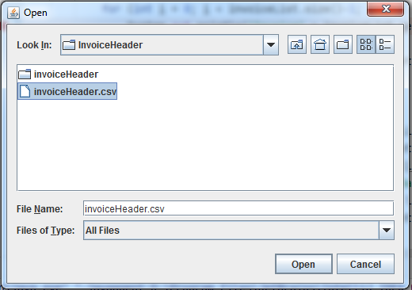

This is the test function result that print All Invoices with its full data:

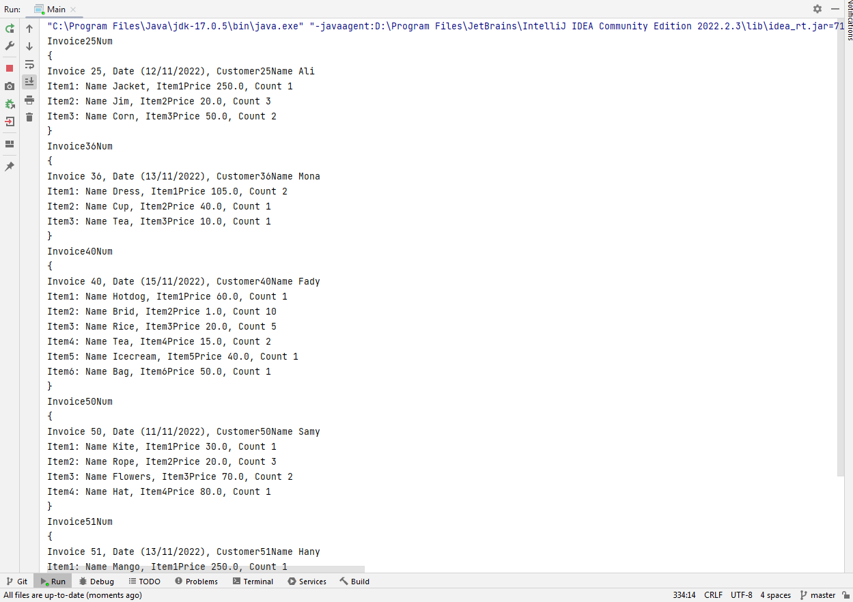

Then the frame will be loaded as shown:

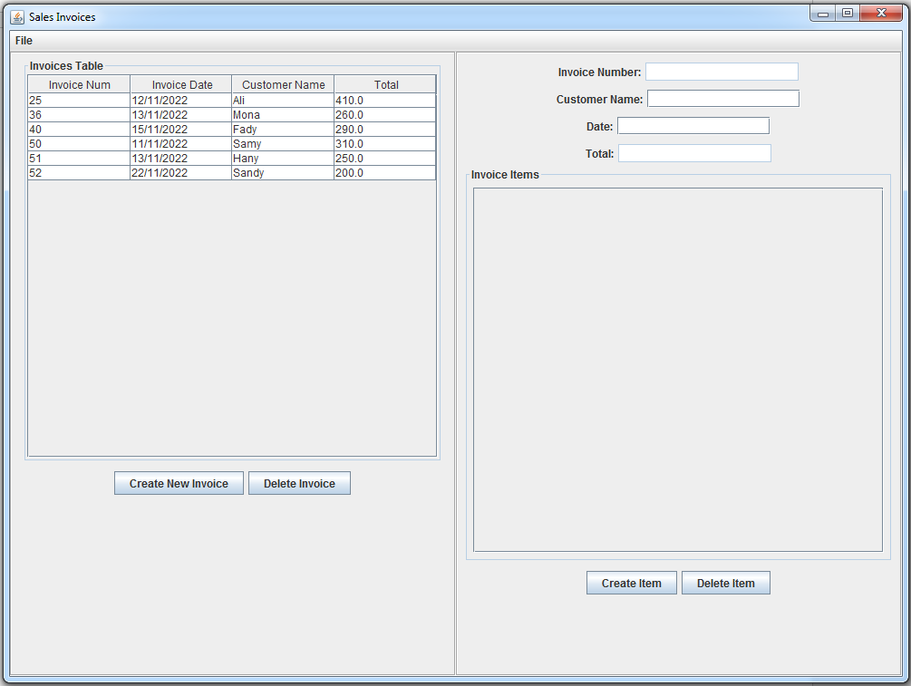

When selecting any invoice from “Invoices Table” in left side, the invoice details shown in the right side as:

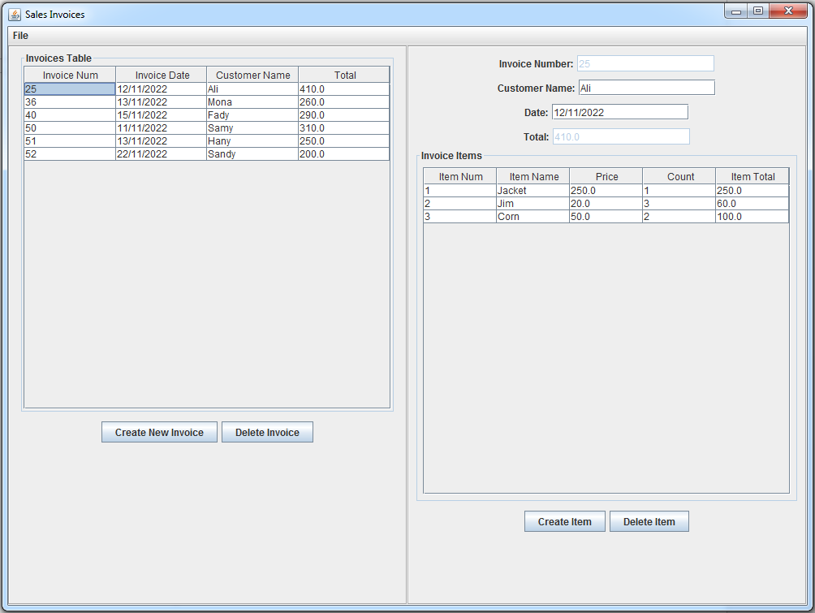

And we can change the invoice details or add item or remove item.